Usecase
===========================================
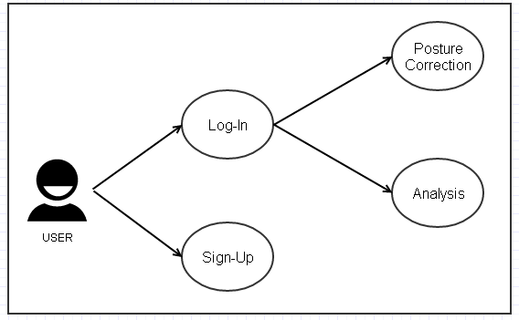 Figure 20 Overall Usecase.

The overall usecase is shown in the Figure 20. Our project’s plattform is Android-Mobile Application. So, first user should download our application and execute the program to do self-orthotherapy. And if user executed the program, a dialog window to get permission of bluetooth and connect with arduino would pop up. Then user will find the proper device and connect with the arduino and finnally could see the first page of our application. After that if user has registered already, user could enter into the next functions like ‘Posture Correction’ or ‘Analysis’. If not, user should sign-up and register user’s data into the program’s database to use this program.

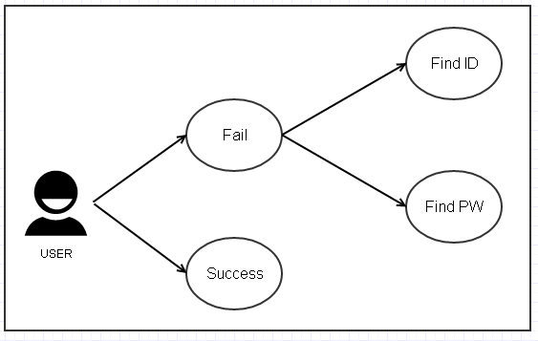 Figure 21 Log-In Usecase.

To use self-orthotherapy program, user should log-in to our system. But if user fails to do log-in, there are two ways of solving this problem. These are ‘Find ID’ and ‘Find PW’. Log-In Usecase is shown in the Figure 21 and the Use Case’s descriptions are written in the table x.

Table x : The description of Log-In Usecase
Use Case | Description
Find ID | There are two ways to solve log-in problem. The first is ‘Find ID’. User could find the own ID by writing the name and E-mail compared to the database’s data.
Find PW | And the second is ‘Find PW’. User coud find the own password by writing the ID, and name compared to the database’s data. It could meet the need of ‘Log-In’ requirement.

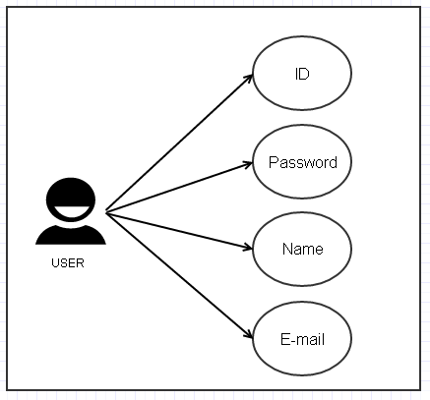 Figure 22 Sign-up Usecase

If user had not registered in our program, user should do sign-up to use the program. There are four componentes to register user’s data into the database. It could meet the need of ‘Sign-Up’ requirement. Sign-Up Usecase is shown in the Figure 22 and the Use Case’s descriptions are written in the table x.

Table x : The description of Sign-Up Usecase.
Use Case | Description
ID | User should make unique ID to sign-up. It should be made of english and numbers under 10 characters. The special letters can not be used to make ID.And, it is mandatory for you to double-check your ID.
Password | There is no limit in the length of the password and the password will be replaced with other letters, such as ****, as soon as you enter your password for the sake of absolute confidentiality.
Name | User should write own full name(first name + last name). And the english only could be used.
E-mail | User should write one e-mail address. User could select the portal’s address like ‘gmail.com’ or ‘naver.com’ or write the addresss in person. After that the permission e-mail will be sent to the written e-mail address. So, it is not possible to do sign-up unless the user do not check the permission e-mail.

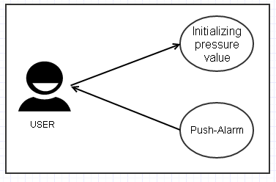 Figure 23 Posture Correction Usecase.

The main function of this program is to correct user’s bad posture when user sits down on the chair. So, setting the user’s own pressure value is mendatory. Because people have different physical size and weight. Initializing pressure value is the function to meet that requirement. After initializing presuure value, user could get alarm message when they keep bad posture. Posture Correction Usecase is shown in the Figure 23 and the Use Case’s descriptions are written in the table x.

Table x : The description of Posture Correction Usecase
Use Case | Description
Initializing Pressure Value | To get posture correction alarm, initializing pressure value is needed. Because our algorithm needs the fixed pressure value suited to the user. So, average of 5 times pressure values(when user sit down to the cushion, the pressure values are recognized.)is selected as the initial pressure value of user.
Push-Alarm | If user has wrong posture, program would recognize that status using posture correction algorithm. And the push alarm will be poped up to the user’s mobile phone like “Do not make your leg crossed”.

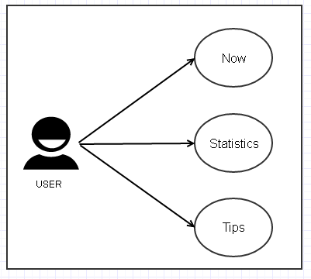 Figure 24 Analysis Usecase.

The another main function of this program is to offer analysis information using user’s posture data. And there are three sub functions in analysis part ‘Now’, ‘Statistics’and ‘Tips’. Analysis Usecase is shown in the Figure 24 and the Use Case’s descriptions are written in the table x.

Table x : The description of Analysis Usecase
Use Case | Description
Now | User could see the two type of time in the ‘Now’ part. First is the the time of user’s actual working hour. And the second is the time how much user keeps good posture and bad posture. And user could see the 3D feature reflecting user’s present posture. So, it could help user recognize their present posture visually.
Statistics | User could see the three type of analysing graphical data such as ‘Day’, ‘Week’ and ‘Month’. The user’s data is saved in the database and the program analyzes that data and shows the graphical graph using that data. So, user could see the data distribution according to the selected period(User could select period by touching the upper tab). It meets the ‘Statistics’ and ‘Visualization’ requirements.
Tips | User could see the some videos about stretching good for posture correction. And some of exercieses which are good for posture correction are recommended in this page.

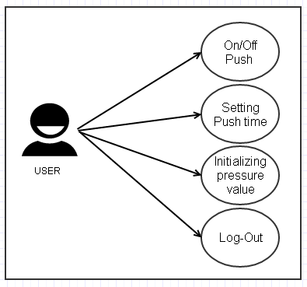 Figure 24 Setting Usecase.

User could do four functions in the Setting page. Those are ‘On/Off Push’, ‘Setting Push time’, ‘Initializing pressure value’ and ‘Log-Out’. This functions could help user cutomize program’s functions. Setting Usecase is shown in the Figure 24 and the Use Case’s descriptions are written in the table x.

Table x : The description of Setting Usecase
Use Case | Description
On/Off Push | User could change the status of push alarm by On/Off. When user has urgent project meetint or needs to keep mobile phone silent, this function would be needed.
Setting Push time | User could set the time when user get the push alarm. The time has range from 1 to 10 minutes. For example, if user selects 2 minutes in this page(Default value is 1 minute)user would get push alarm when user keeps bad posture for 2 minutes.
Initializing pressure value | User could intialize pressure value in this page. The reason why user uses this function is that the actual user could be changed. So, when the actual user is changed the program initializes the pressure value making average value getting five times pressure values.
Log-Out | User could do Log-Out in this page. This function is required when user do not want to use this program or take out his/her own data to the database.

